**Notes for LAMP stack creation using Digital Ocean – Instructions to recreate the color app**

You will need a digitalocean.com account for this. I suggest being logged onto the account before you begin. You will also need to have purchased a domain. I am using COP4331-5.com since I already own it and am not using it. .xyz domains are inexpensive, so you might want to consider those.

The digital ocean hosting will cost $6 per month, and you will need it for two months. The domain will cost something, too.

***Hosting***

Go to <https://marketplace.digitalocean.com/apps/lamp>

**Create a LAMP Droplet**

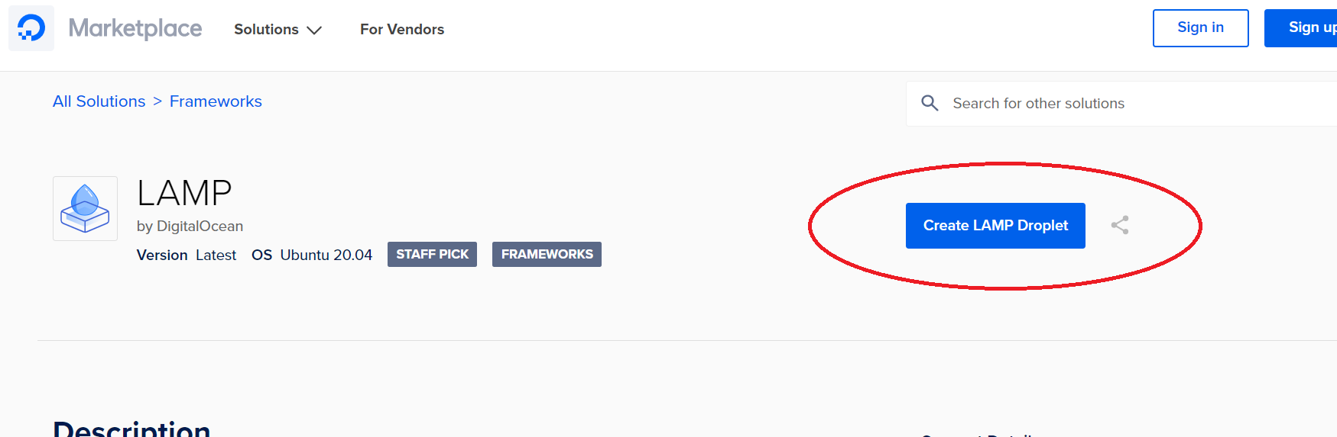

**Select Ubuntu, Basic Plan, and the *Create***

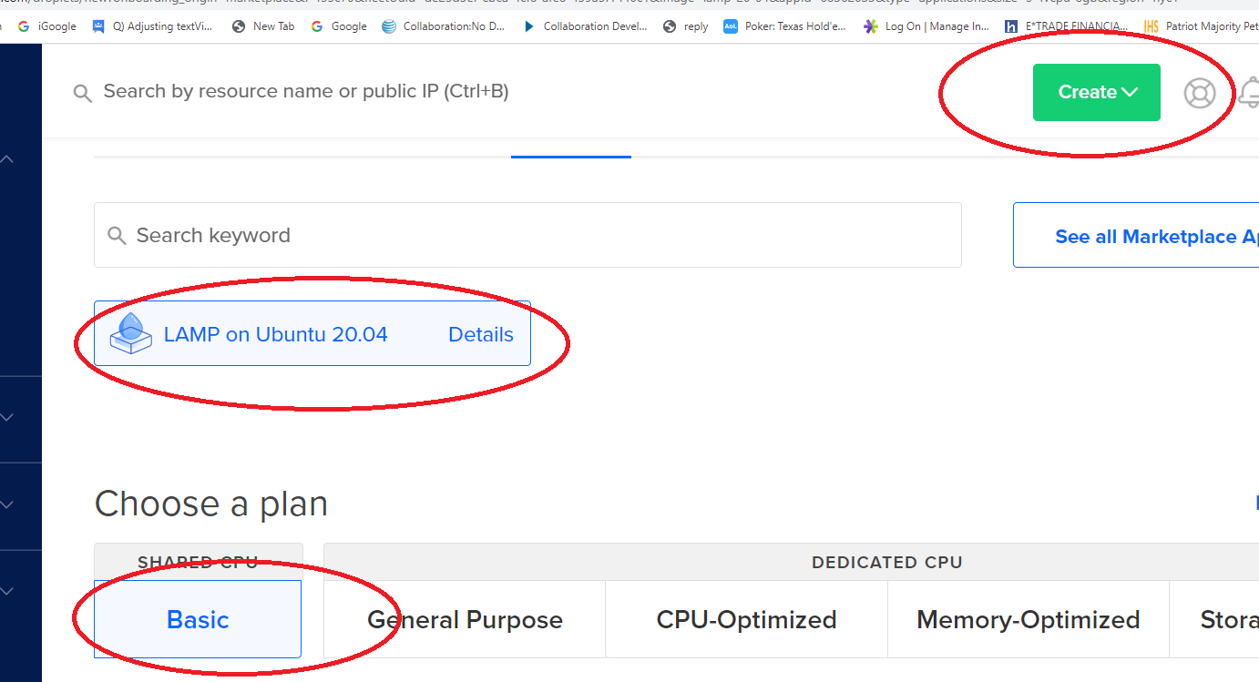

You will need to select the $5 (now $6) / mo plan. Also, create a root password. The droplet will then be provisioned while you wait several minutes.

Once done, click **Get started**

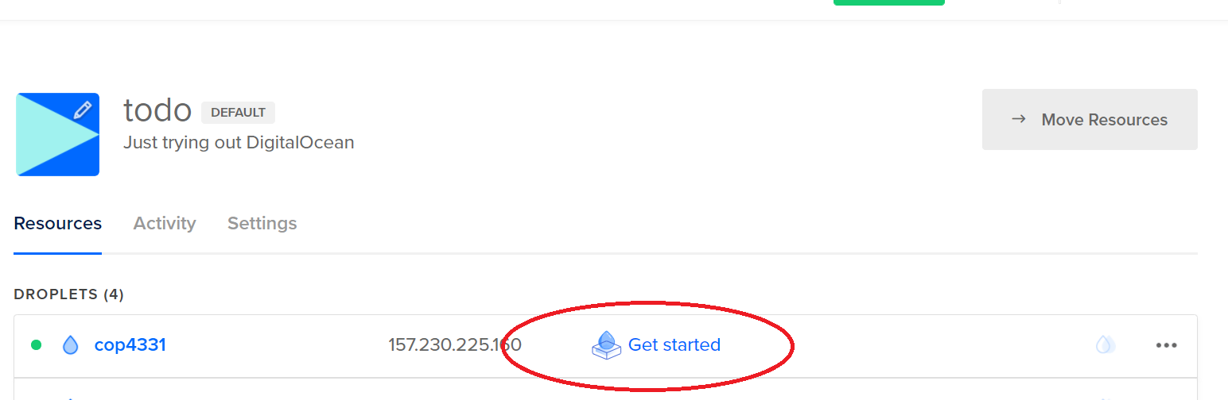

**Install Putty in order to easily SSH in to your droplet**

Run PuTTY and put in IP address

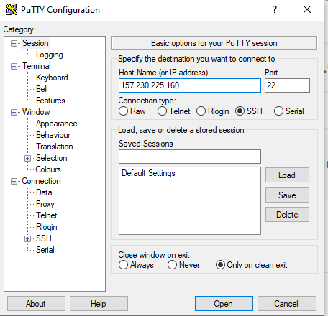

Enter user name (should be root) and password

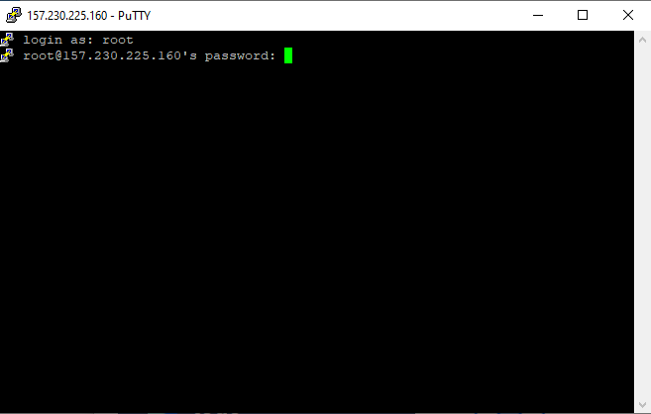

Please note that everything you essentially need is already installed.

Navigate to the root – **cd /root**

Optional: Get your MySQL password as follows: **vi .digitalocean_password** (;q to quit vi)

The web root is in /var/www/html – Go to that directory now with **cd /var/www/html**

View the contents of the directory with **ls**

View the contents of index.html with **cat index.html** – it’s a lot

Now we will edit the contents of index.html – open for editing with **vi index.html**

You can highlight and delete a block by positioning the cursor at the top of the block and pressing Shift-V, cursoring down to the end of the block and pressing d

You need to<body> be in insert mode, so press the insert key

Your index.html file should look like the following:

<html>  
 <body>  
 <h1>We love COP 4331</h1>  
 </body>  
</html>

To save and quit hit the **escape key** (to get out of insert mode), type **:wq** – now verify the edit with **cat index.html**

You can access this via a web browser. Open a browser and type in your http://IP address.

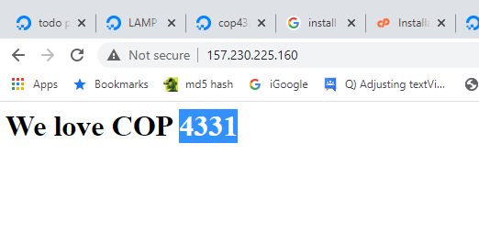

Now for a domain. You cannot buy a domain through digital ocean. Choose another domain registrant. I use GoDaddy, but there are lots of them. Purchase a domain and point the domain to your digital ocean applet. Below are the steps I took on GoDaddy.

1. I already had this domain purchased:



2. Navigate to the DNS manager:

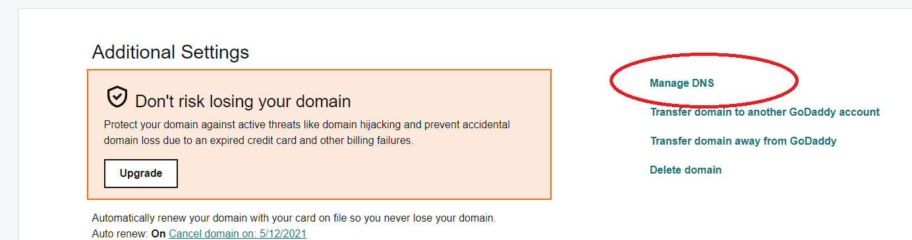

3. Edit the IP address and save:

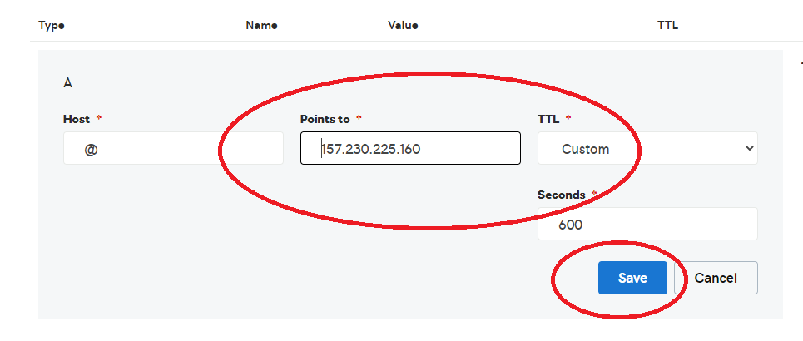

4. Test with a browser. It might take a few minutes to propagate. (On Windows it is helpful to go to a command prompt and type **ipconfig /flushdns**) You might also want to use Ctrl-F5 to hard reset the web content.

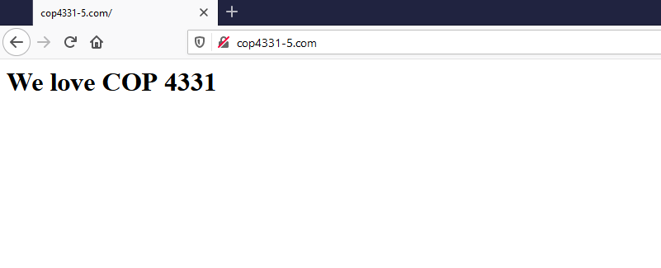

**Get started**

Option: Connect to MySQL: **mysql -u root -p** (then enter your password)

Here are the steps to create the database, tables, and working data.

**1. Create database**

create database COP4331;

use COP4331;

**2. Create tables**

CREATE TABLE `COP4331`.`Users` ( `ID` INT NOT NULL AUTO_INCREMENT , `DateCreated` DATETIME NOT NULL DEFAULT CURRENT_TIMESTAMP , `DateLastLoggedIn` DATETIME NOT NULL DEFAULT CURRENT_TIMESTAMP , `FirstName` VARCHAR(50) NOT NULL DEFAULT '' , `LastName` VARCHAR(50) NOT NULL DEFAULT '' , `Login` VARCHAR(50) NOT NULL DEFAULT '' , `Password` VARCHAR(50) NOT NULL DEFAULT '' , PRIMARY KEY (`ID`)) ENGINE = InnoDB;

CREATE TABLE `COP4331`.`Colors` ( `ID` INT NOT NULL AUTO_INCREMENT , `Name` VARCHAR(50) NOT NULL DEFAULT '' , `UserID` INT NOT NULL DEFAULT '0' , PRIMARY KEY (`ID`)) ENGINE = InnoDB;

**3. Populate working data rows**

USE COP4331;

insert into Users (FirstName,LastName,Login,Password) VALUES ('Rick','Leinecker','RickL','COP4331');

insert into Users (FirstName,LastName,Login,Password) VALUES ('Sam','Hill','SamH','Test');

insert into Users (FirstName,LastName,Login,Password) VALUES ('Rick','Leinecker','RickL','5832a71366768098cceb7095efb774f2');

insert into Users (FirstName,LastName,Login,Password) VALUES ('Sam','Hill','SamH','0cbc6611f5540bd0809a388dc95a615b');

insert into Colors (Name,UserID) VALUES ('Blue',1);

insert into Colors (Name,UserID) VALUES ('White',1);

insert into Colors (Name,UserID) VALUES ('Black',1);

insert into Colors (Name,UserID) VALUES ('gray',1);

insert into Colors (Name,UserID) VALUES ('Magenta',1);

insert into Colors (Name,UserID) VALUES ('Yellow',1);

insert into Colors (Name,UserID) VALUES ('Cyan',1);

insert into Colors (Name,UserID) VALUES ('Salmon',1);

insert into Colors (Name,UserID) VALUES ('Chartreuse',1);

insert into Colors (Name,UserID) VALUES ('Lime',1);

insert into Colors (Name,UserID) VALUES ('Light Blue',1);

insert into Colors (Name,UserID) VALUES ('Light Gray',1);

insert into Colors (Name,UserID) VALUES ('Light Red',1);

insert into Colors (Name,UserID) VALUES ('Light Green',1);

insert into Colors (Name,UserID) VALUES ('Chiffon',1);

insert into Colors (Name,UserID) VALUES ('Fuscia',1);

insert into Colors (Name,UserID) VALUES ('Brown',1);

insert into Colors (Name,UserID) VALUES ('Beige',1);

insert into Colors (Name,UserID) VALUES ('Blue',3);

insert into Colors (Name,UserID) VALUES ('White',3);

insert into Colors (Name,UserID) VALUES ('Black',3);

insert into Colors (Name,UserID) VALUES ('gray',3);

insert into Colors (Name,UserID) VALUES ('Magenta',3);

insert into Colors (Name,UserID) VALUES ('Yellow',3);

insert into Colors (Name,UserID) VALUES ('Cyan',3);

insert into Colors (Name,UserID) VALUES ('Salmon',3);

insert into Colors (Name,UserID) VALUES ('Chartreuse',3);

insert into Colors (Name,UserID) VALUES ('Lime',3);

insert into Colors (Name,UserID) VALUES ('Light Blue',3);

insert into Colors (Name,UserID) VALUES ('Light Gray',3);

insert into Colors (Name,UserID) VALUES ('Light Red',3);

insert into Colors (Name,UserID) VALUES ('Light Green',3);

insert into Colors (Name,UserID) VALUES ('Chiffon',3);

insert into Colors (Name,UserID) VALUES ('Fuscia',3);

insert into Colors (Name,UserID) VALUES ('Brown',3);

insert into Colors (Name,UserID) VALUES ('Beige',3);

We will create a user:

Use COP4331;

create user 'TheBeast' identified by 'WeLoveCOP4331';

Now we need to grant permissions to the database for that user:

grant all privileges on COP4331.* to 'TheBeast'@'%';

The database is ready to use.

**Here: Talk about primary and foreign keys**

The web directory hierarchy is as follows:

root (/var/www/html)

css (/var/www/ html /css)

images (/var/www/ html /images)

js (/var/www/ html /js)

LAMPAPI (/var/www/ html /LAMPAPI)

index.html

color.html

Navigate to /var/www/html

Create the directories

**mkdir css**

**mkdir images**

**mkdir js**

**mkdir LAMPAPI**

***API***

There will be three API endpoints: **AddColor**, **Login**, and **SearchColors**. They each have a single .php file that is contained in the LAMPAPI directory.

Please note that there is a php statement that must be changed with your database username, password, and database name.

$conn = new mysqli("localhost", "username", "password", "database");

For our example that becomes

$conn = new mysqli("localhost", "TheBeast", "WeLoveCOP4331", "COP4331");

There are three example .php files in the stacks\LAMP\LAMPAPI path of the file on the webcourse.

Upload the .php files to the server. They will be placed into LAMPAPI.

Run PuTTY FTP.

Type open COP4331-5.com (your domain name)

Enter username and password

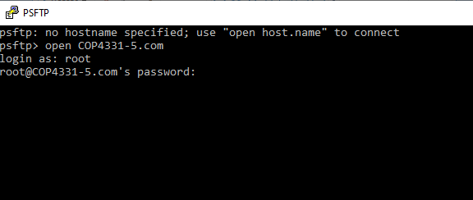

Type cd /var/www/html

You can type ls to see the subdirectories

Enter the LAMPAPI directory (**cd LAMPAPI**)

Now you will upload the API endpoint files with the following:

put "D:\work\USBSticks\UCF USB Stick Fall 2021\COP 4331\Slides and Related Material\LAMP Stack\LAMPAPI\AddColor.php"

put "D:\work\USBSticks\UCF USB Stick Fall 2021\COP 4331\Slides and Related Material\LAMP Stack\LAMPAPI\Login.php"

put "D:\work\USBSticks\UCF USB Stick Fall 2021\COP 4331\Slides and Related Material\LAMP Stack\LAMPAPI\SearchColors.php"

Use the ls command to double check that the files have been uploaded

***Remember that Linux is case sensitive for file names and directories***

**Here: analysis of .php API endpoint files.**

Now the API endpoints can be tested.

Use ARC or Postman or CURL or Swagger

http://cop4331-5.com/LAMPAPI/Login.php

login

password

http://cop4331-5.com/LAMPAPI/AddColor.php

userId

color

http://cop4331-5.com/LAMPAPI/SearchColors.php

userId

search

***Front End***

Upload css, images, js directories. Also upload color.html and index.html

cd css

put "D:\work\USBSticks\UCF USB Stick Fall 2021\COP 4331\Slides and Related Material\LAMP Stack\css\styles.css"

cd ../images

put "D:\work\USBSticks\UCF USB Stick Fall 2021\COP 4331\Slides and Related Material\LAMP Stack\images\ background.png"

cd ../js

put "D:\work\USBSticks\UCF USB Stick Fall 2021\COP 4331\Slides and Related Material\LAMP Stack\js\code.js"

put "D:\work\USBSticks\UCF USB Stick Fall 2021\COP 4331\Slides and Related Material\LAMP Stack\js\md5.js"

cd ..

put "D:\work\USBSticks\UCF USB Stick Fall 2021\COP 4331\Slides and Related Material\LAMP Stack\index.html"

put "D:\work\USBSticks\UCF USB Stick Fall 2021\COP 4331\Slides and Related Material\LAMP Stack\color.html"

**Here: Analysis of all source code**

Hashing passwords

insert into Users (FirstName,LastName,Login,Password) VALUES ('Rick','Leinecker','RickL','5832a71366768098cceb7095efb774f2');

insert into Users (FirstName,LastName,Login,Password) VALUES ('Sam','Hill','SamH','0cbc6611f5540bd0809a388dc95a615b');